**Docker Task -03  
==============**

**1) Create a image from running container.**

CMD: docker commit

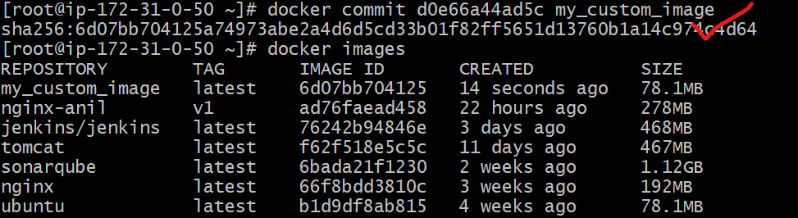

**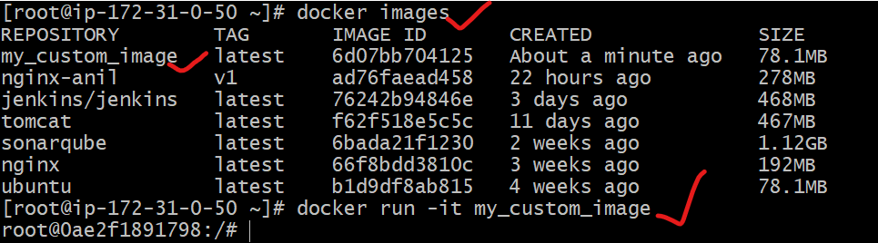  
2) Copy image from local machine to docker server and load the image.**

Prerequisite:

Ensure you have Docker Desktop installed on your local machine. Docker Desktop is required to pull images from a central repository to your local environment. This image available from my local laptop.

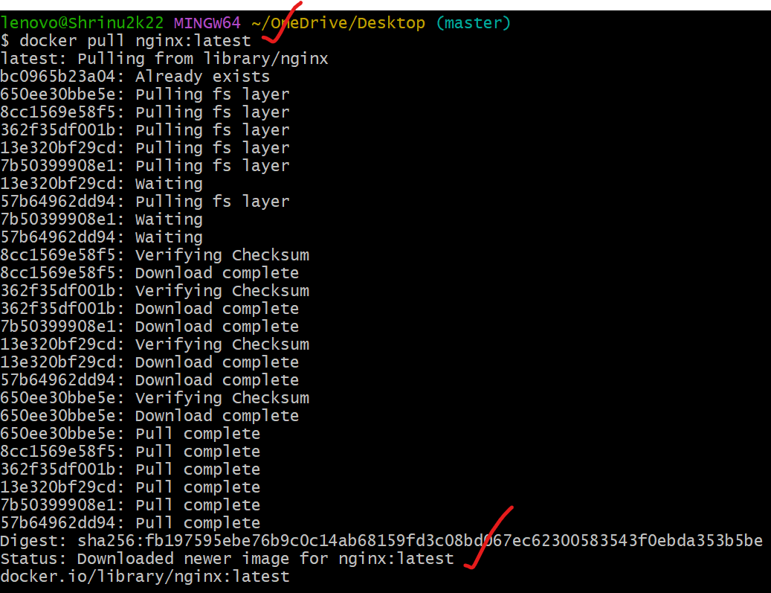

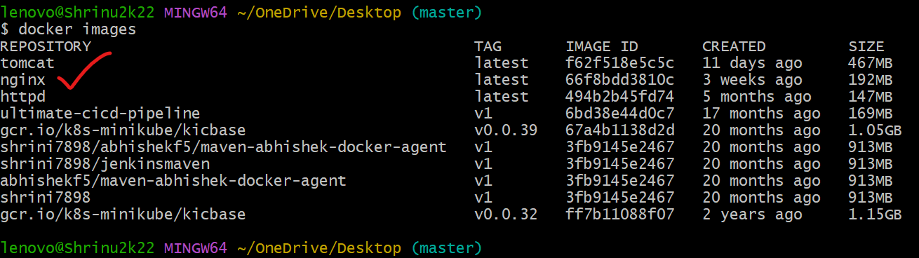

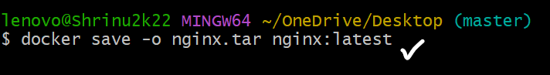

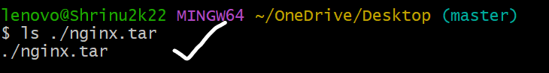

**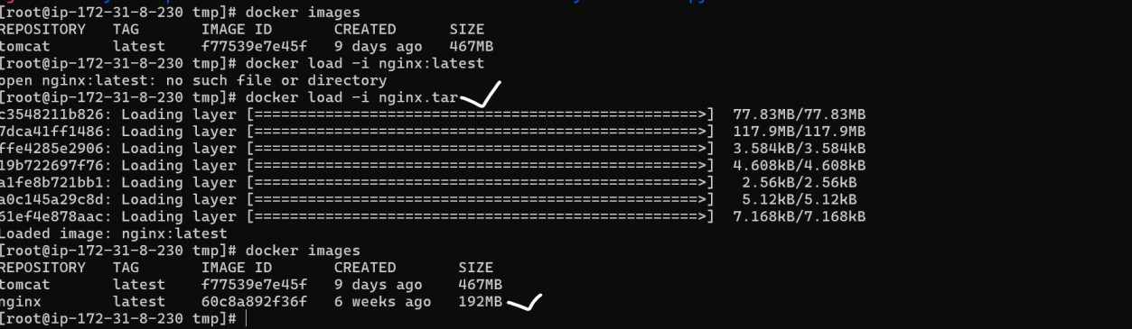  
3) Create Docker image using alpine and customize with tomcat.**

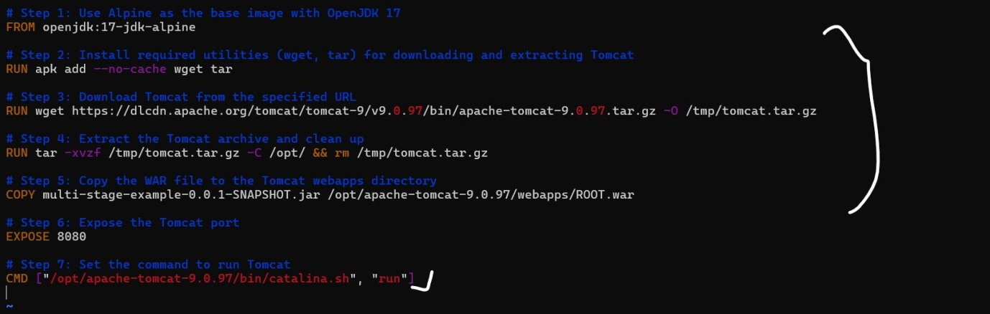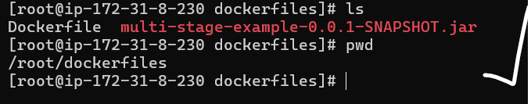

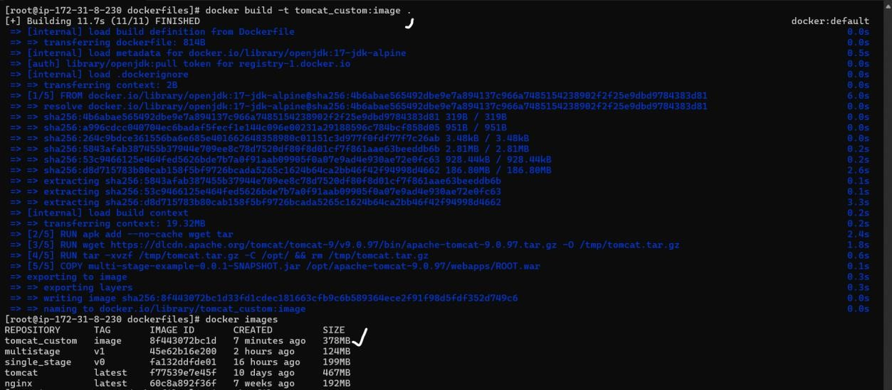

**4) Create single stage and multi stage docker file using the below source code.**[**https://github.com/betawins/multi-stage-example.git**](https://github.com/betawins/multi-stage-example.git)

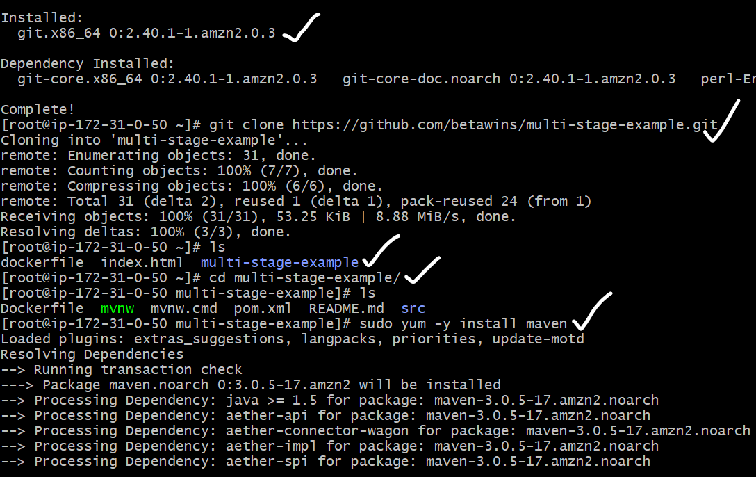

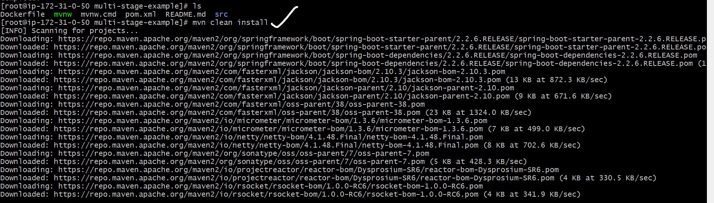



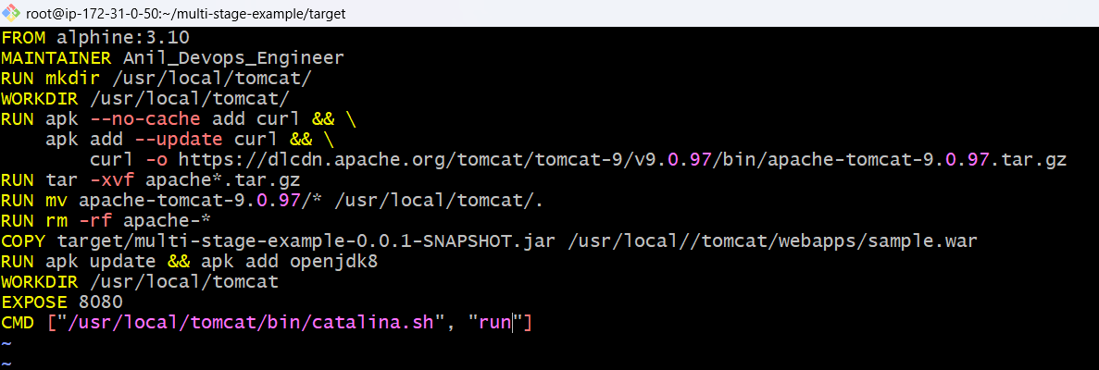

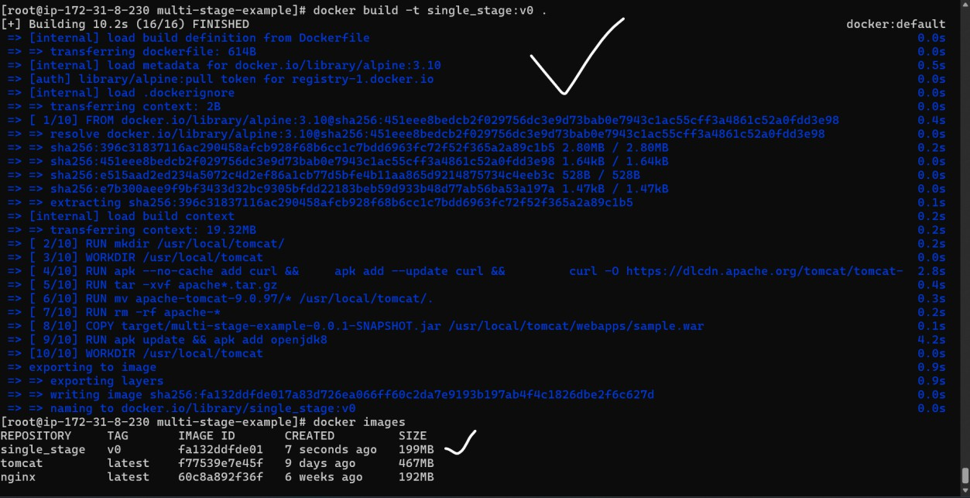

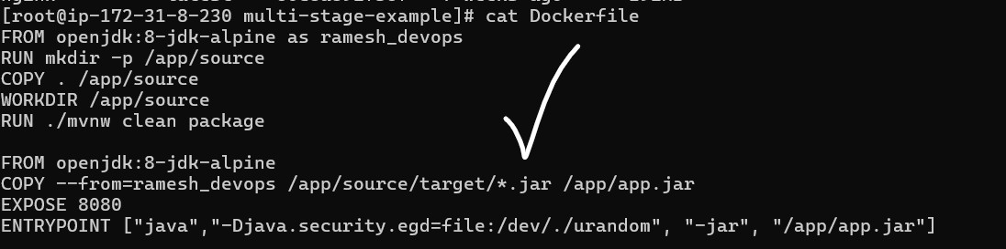

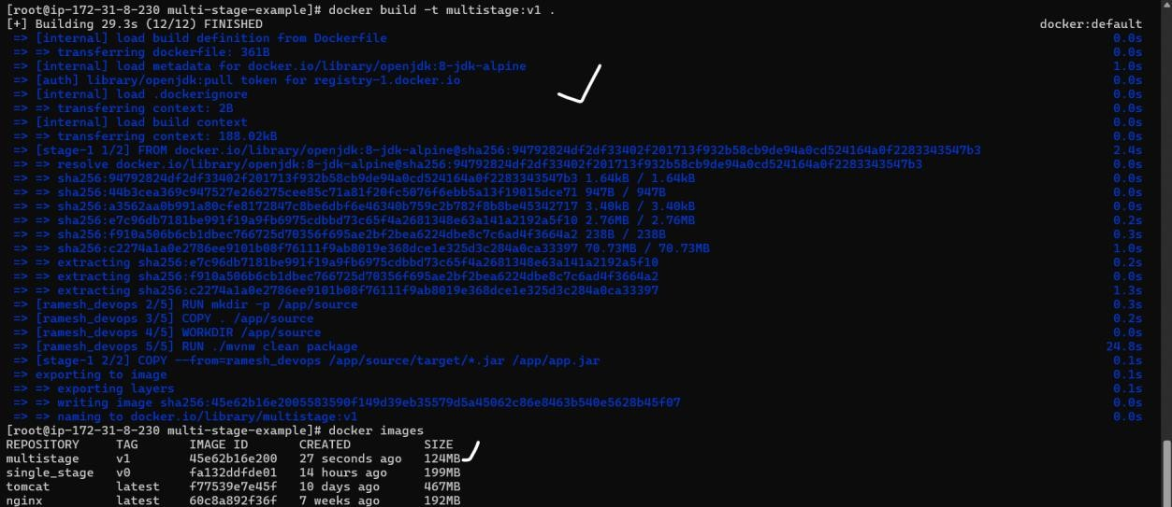

**5) Install docker compose and execute sample applciation.**



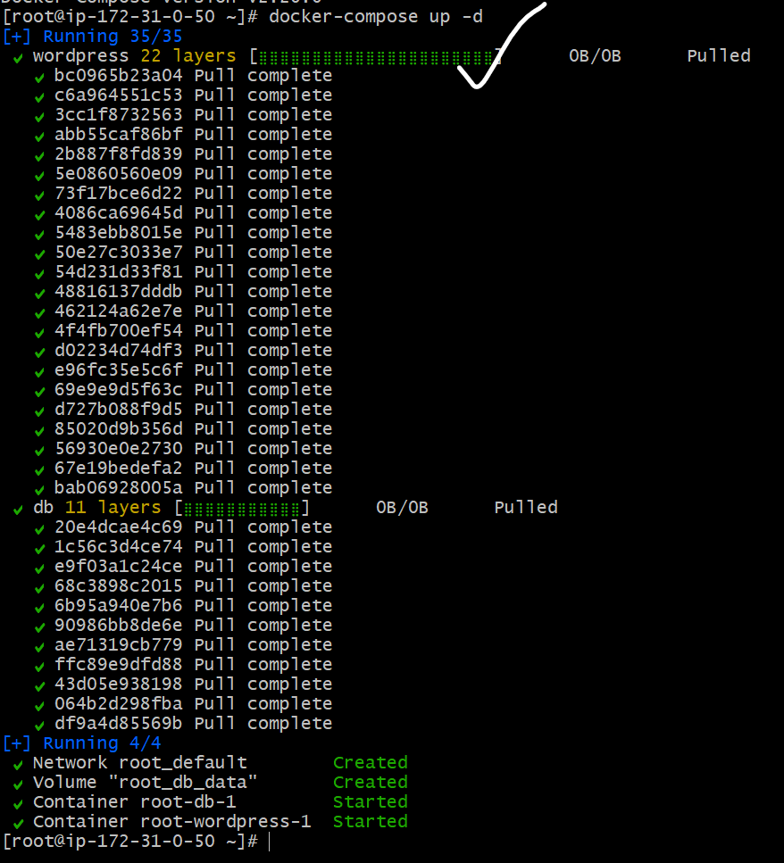

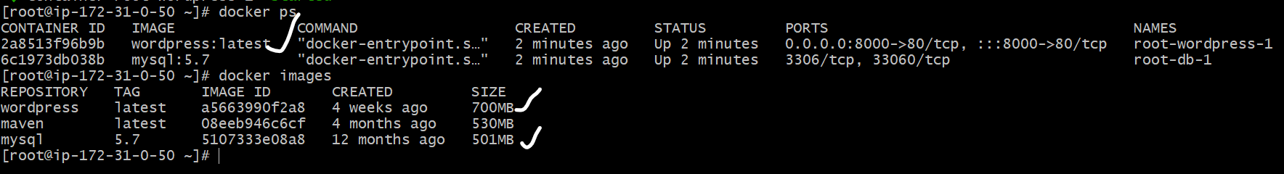

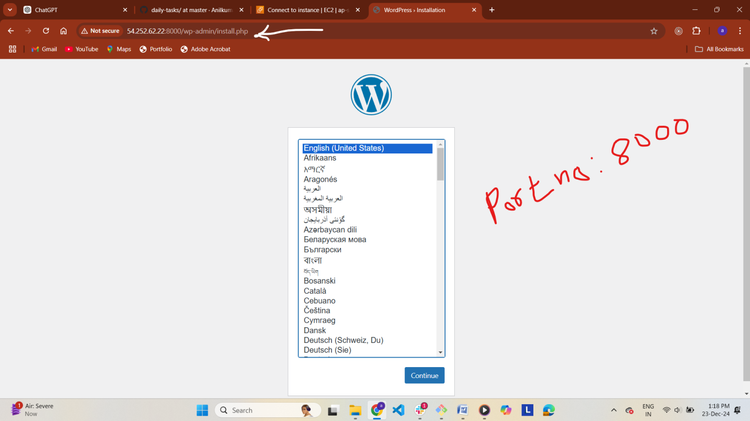

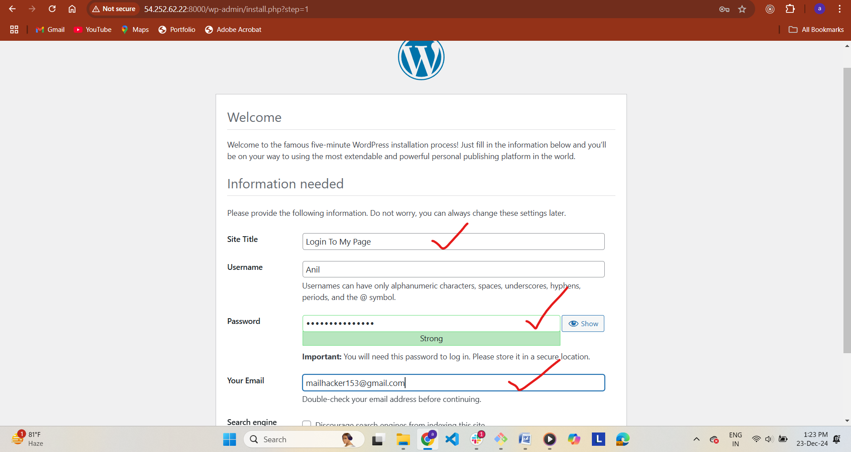

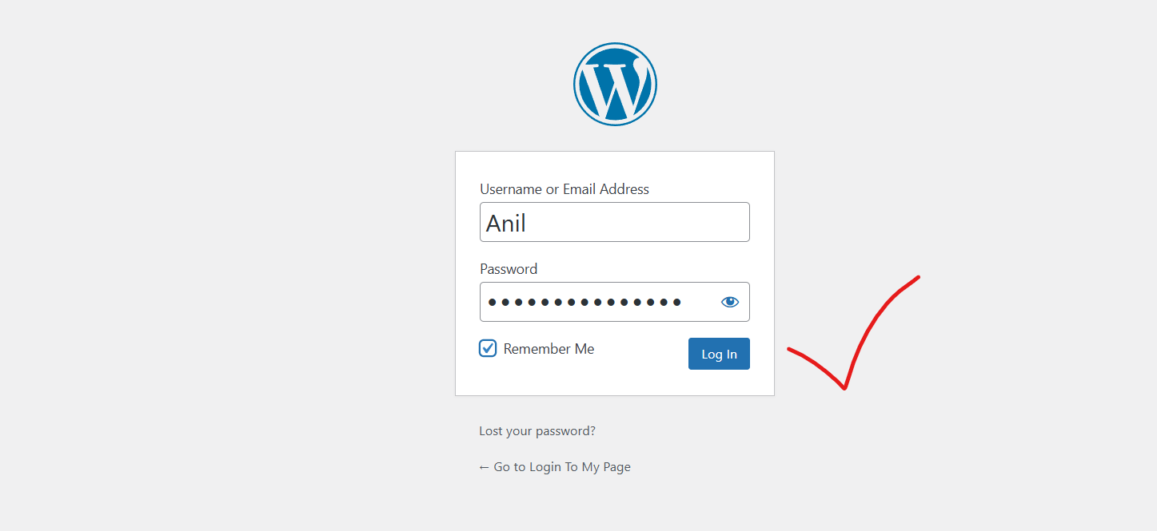

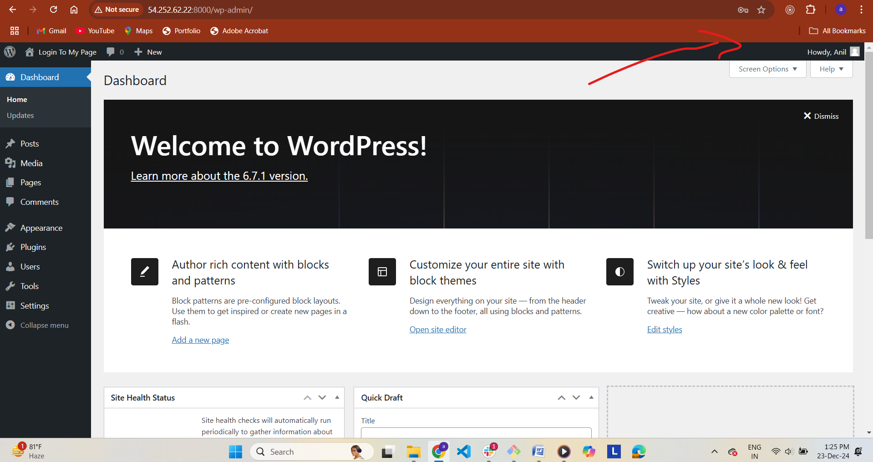

**6) Implement solution to scan images when pushed to**

**docker registry.**

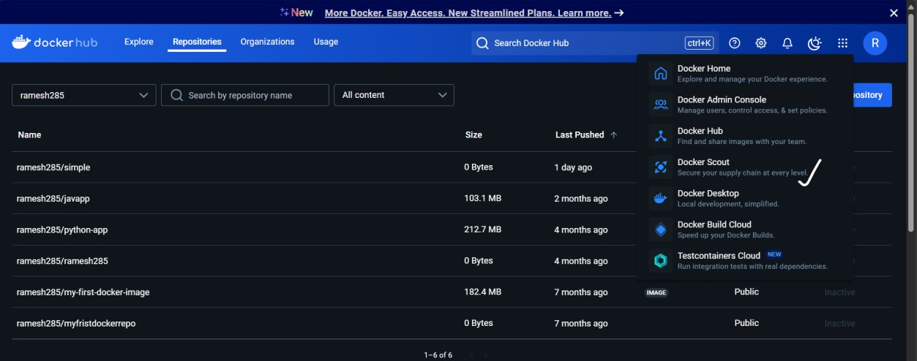

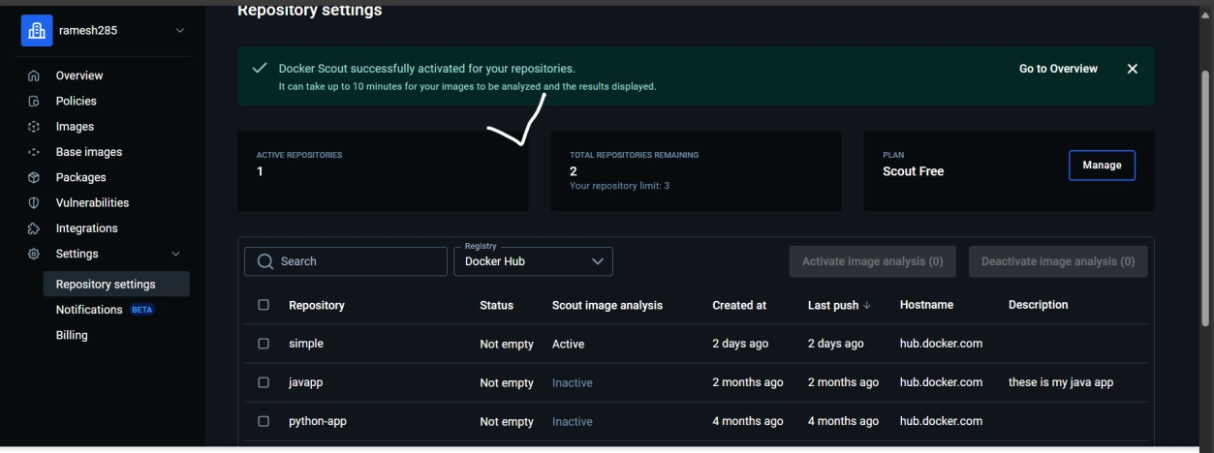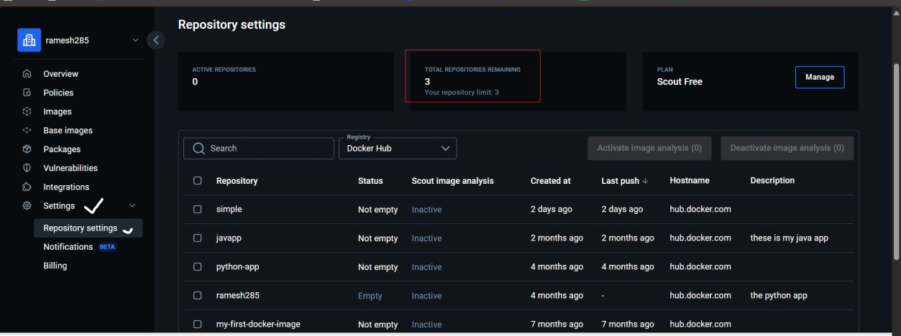

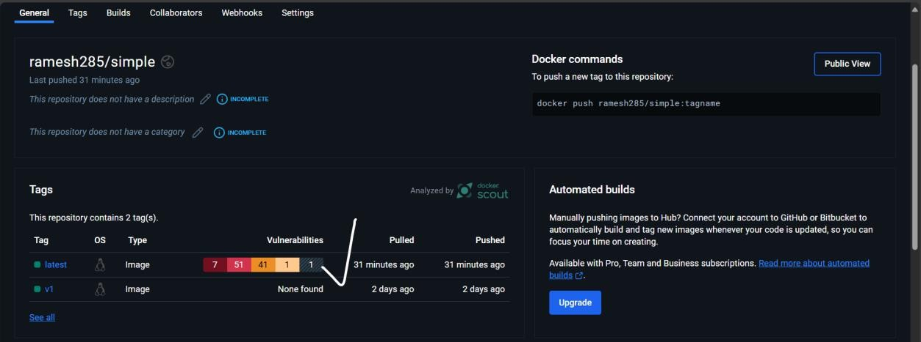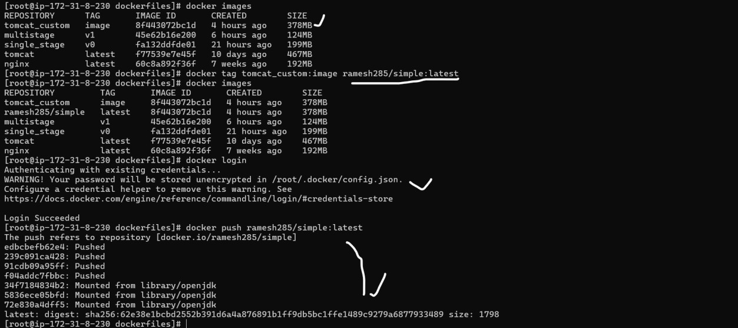

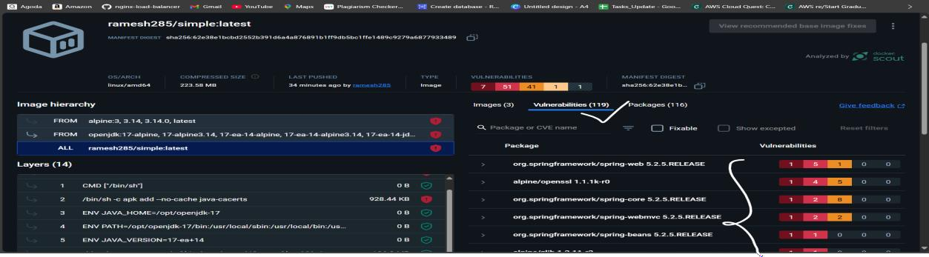

**7) Implement solution to scan images when pushed to aws ecr.**

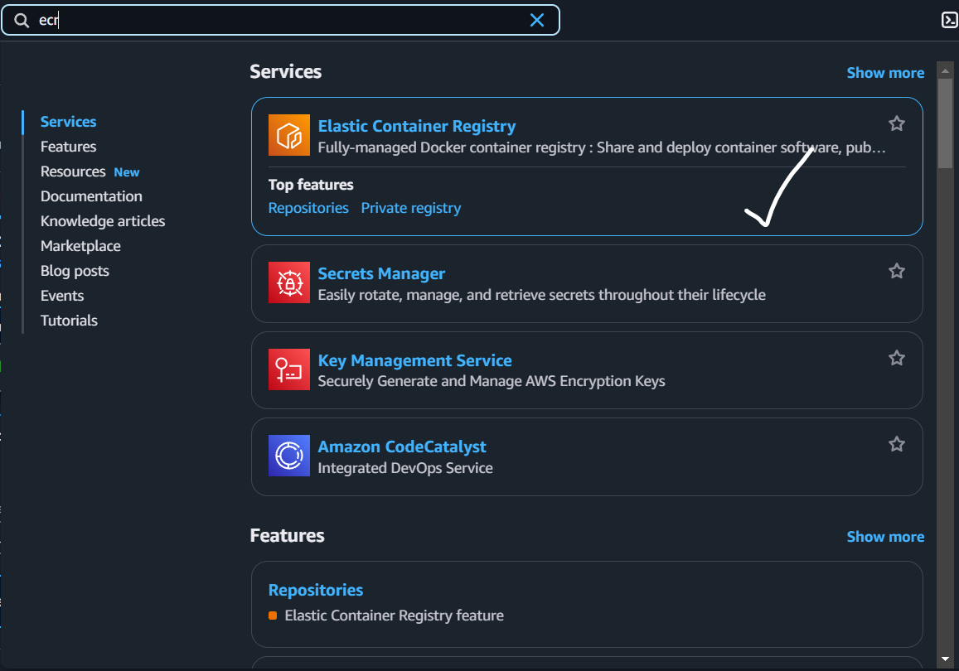

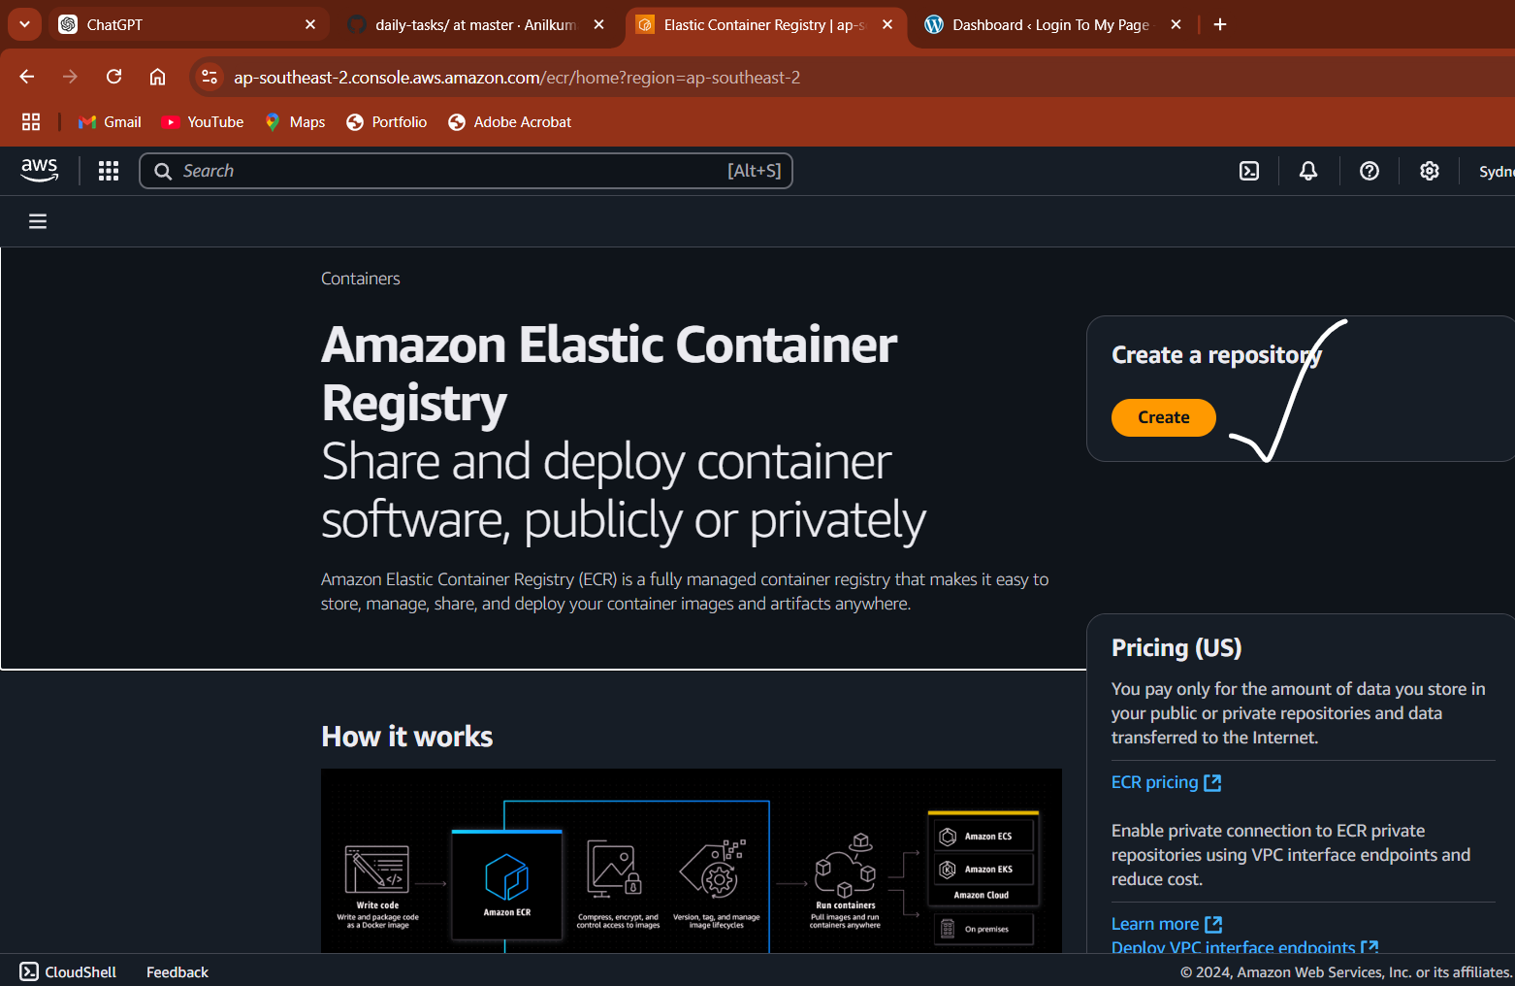

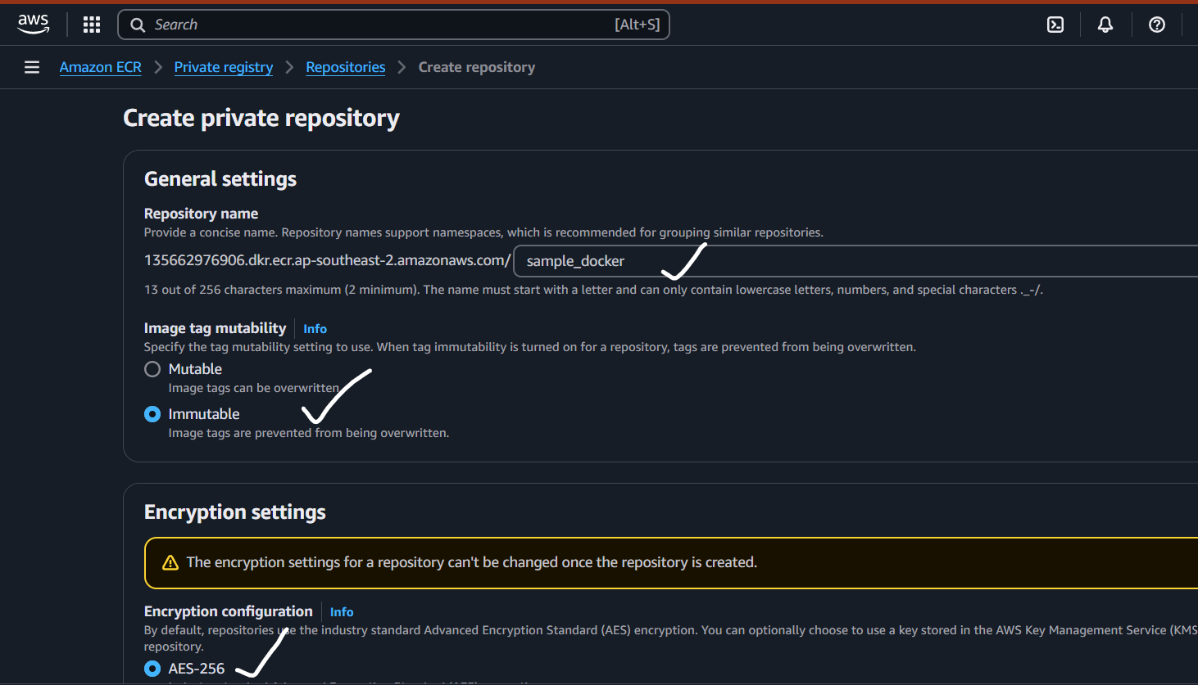

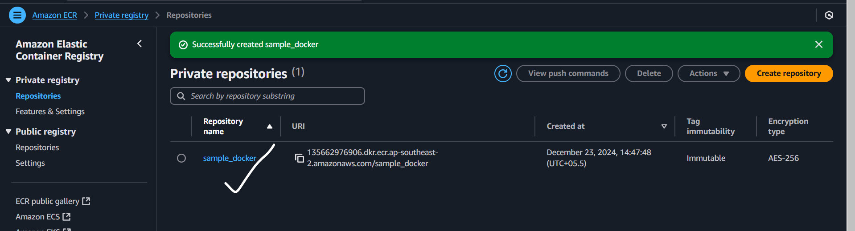

**8) Create a jenkins pipeline to create a docker image and push the image to dockerhub.  
